Name: Lebohang Molise
Student Number: 224078106
Individual Contributions and Reflections

- Responsible for compiling the Initial SRS (Unit 1)
  - Ensured appropriate format for the required SRS
  - Undertook the initial review of the SRS (Unit 1)
  - Ensured the project scope, problem statement, and the aims and objectives of the project were outlined correctly
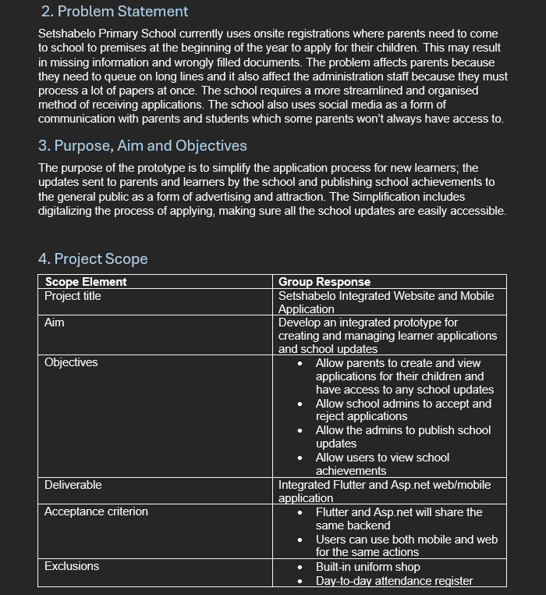

- Responsible for creating and configuring the initial GitHub workplace
  - Created the organization that includes all the required repositories
  - Made sure the Flutter and ASP.net repositories are ready for the upcoming phases
  - Made sure to create a separate repository to store important information and documentations of other members and the group
  - Invited all the members to the GitHub Organization
  - Created the ReadMe Files for multiple repositories

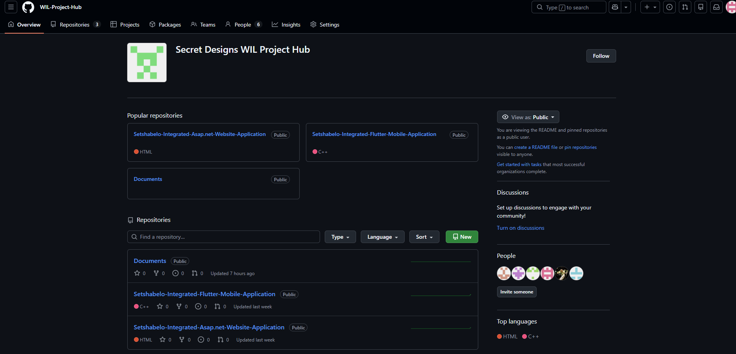
GitHub Organization with the specified repositories

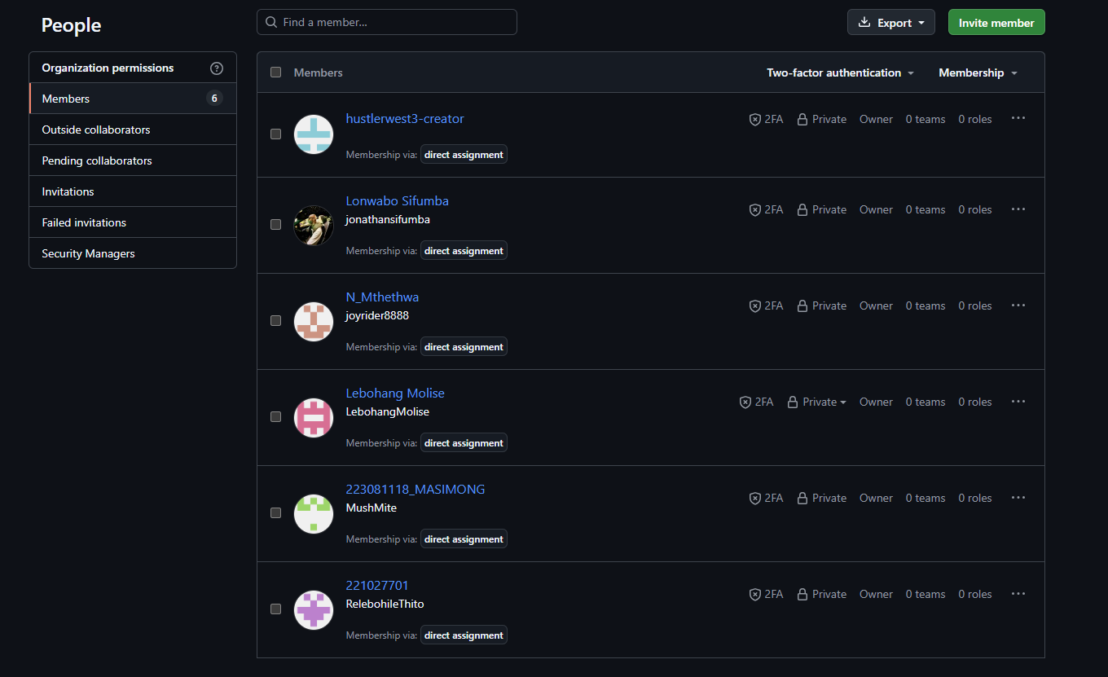
Group members added to the GitHub Organization

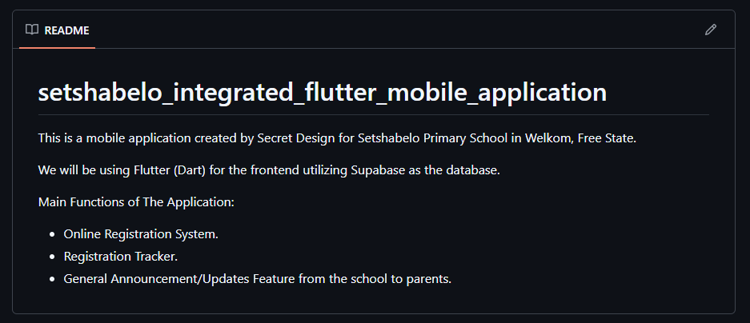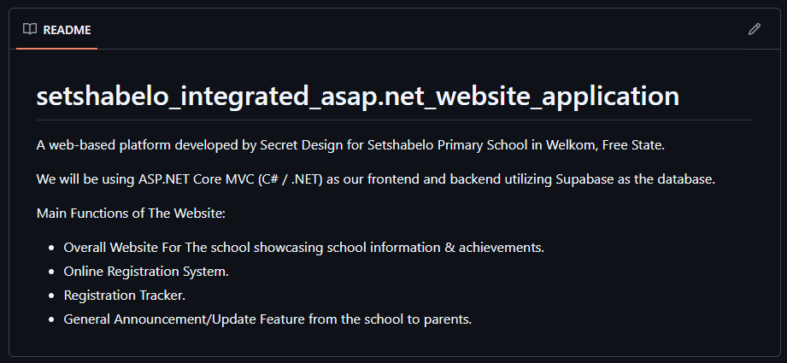
ReadMe Files created for specified repositories

- Create the initial Supabase Project workplace
  - Set up the Supabase and prepare for the upcoming integration phases
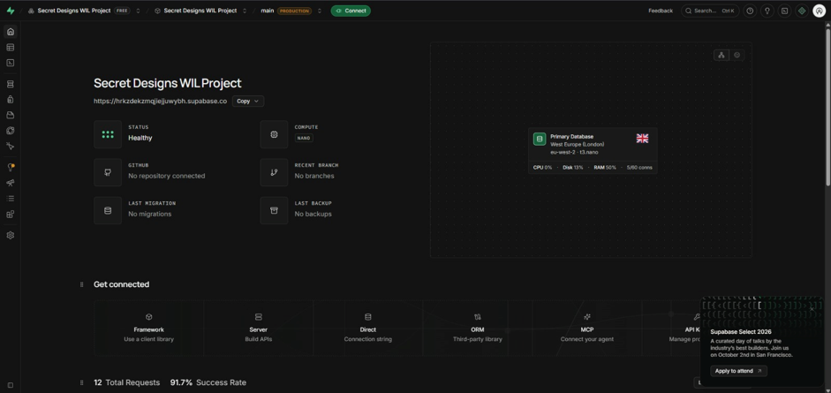
The initial Supabase workplace

- Refine the SRS and Project Plan (Unit 2)
  - Ensured the SRS includes Unit 2’s work
  - Undertook the initial review of the SRS (Unit 2)
  - Ensured the project scope, problem statement, and the aims and objectives of the project were updated correctly
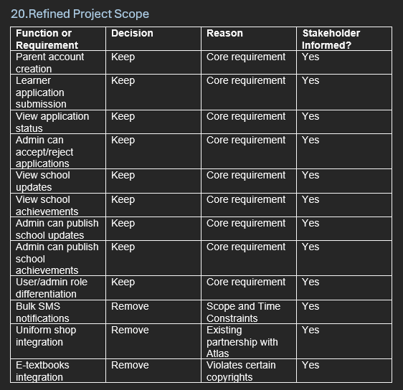
Refined Scope for Unit 2

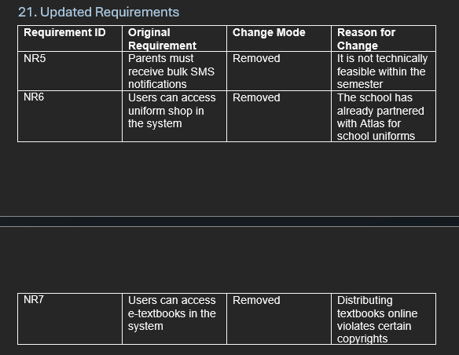
Updated Requirements based on Unit 2

